Explore Data in Power BI Desktop

# Exercise 5

Create visualizations to find the answers to the following questions:

1. Which genre has the most movie titles in the top 250? How many titles? Which genre has the least?
2. Which release year was the most popular in terms of number of movies? Which year was the most popular in number of votes?
3. Create groups on the Rated attribute:

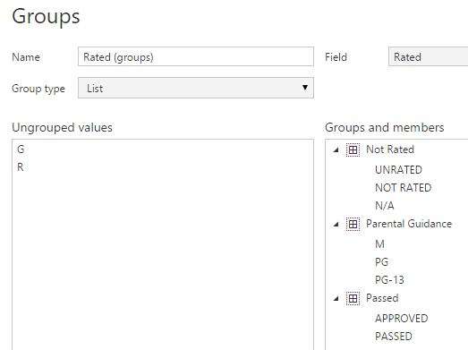

Create the following graph:

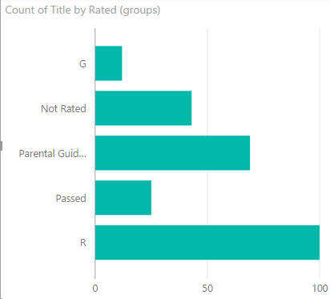

Now create this one:

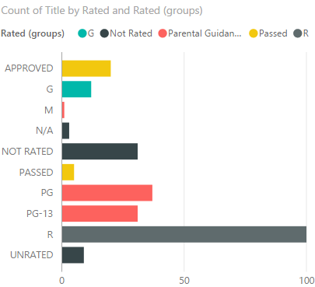

1. Create the following chart. The reference line is the 90% percentile.

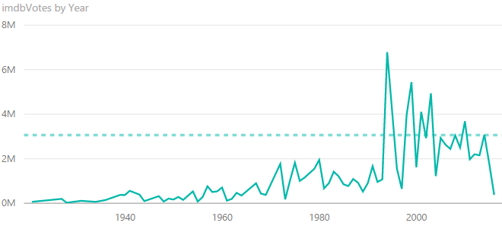

1. Create the following bar chart:

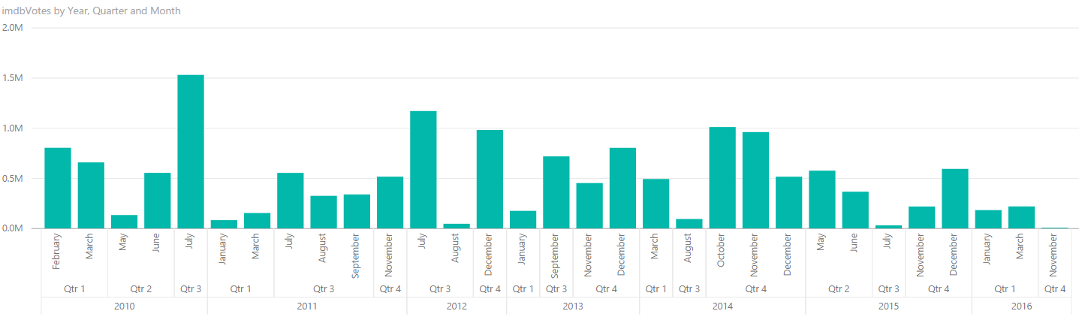

1. Construct this scatter plot. Use clustering for the color.

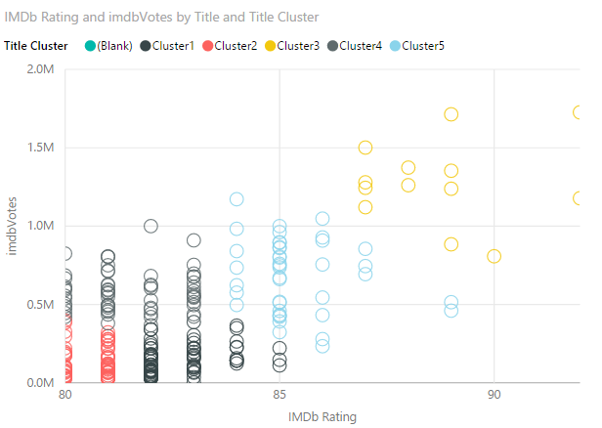

1. Create a histogram by binning the runtime measure into groups of 20. In which interval are the most movies?

(the solutions can be found in Start-Ex6.pbix)